ANNA POLUEKTOVA 100786356

System Design

Portfolio

**Table of content**

1. Lab 1 (Three Layered Use Case Realization through Sequence Diagrams).…...…pg.2

1.1. The First Cut Sequence Diagram……………………..……………………..……...…pg.2

1.2. Three Layered Sequence Diagram……………….…………………………………..pg.3

1.3. Design Class Diagram………………….…………………………………………………..pg.4

1.4. Package Diagram………………….………………………………………………………....pg.5

2. Lab 2 (Three Layered Use Case Realization through Sequence Diagrams)………pg.6

2.1. Class Diagram………………….…………………………………………………………..….pg.6

2.2. Three Layered Sequence Diagram……………….…………………………………..pg.7

3. Lab 3 (Creating an ER Diagram)…………………….……………………………………………...pg.8

3.1. Fully Normalized ER Diagram…………………..……………………………………..pg.8

3.2. Generated Class Diagram………………….……………………………………………..pg.9

4.Lab 4 (USE Scenarios and Windows Navigation Diagram)…………………………....pg.10

4.1. Use Scenarios…………………..……………………………………………………………pg.10

4.2. Windows Navigation Diagram……………….……………………………….……...pg.11

4.3. Language Prototype for HCI………………..……………………………………pg.12-15

5. Lab 5 (Design Statecharts)…...………………………………..……………………………………pg.16

5.1. In-Class Example…………………..………………………………………………………pg.16

5.2. Real Estate Listing System Example….…………………………………………...pg.17

6. Lab 6 (Deployment Diagram)…………………………………………………………………….….p.18

1. Three Layered Use Case Realization through Sequence Diagrams
   1. The First Cut Sequence Diagram

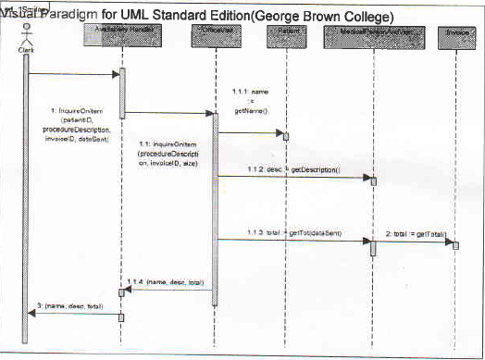

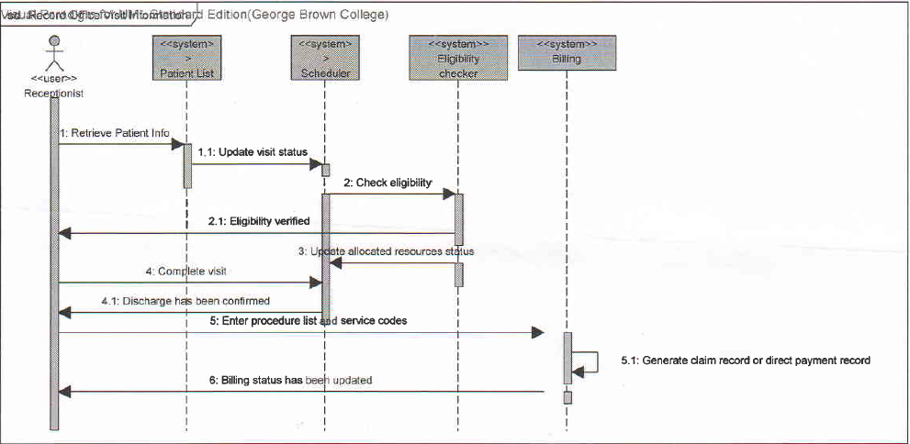

* 1. Three Layered Sequence Diagram

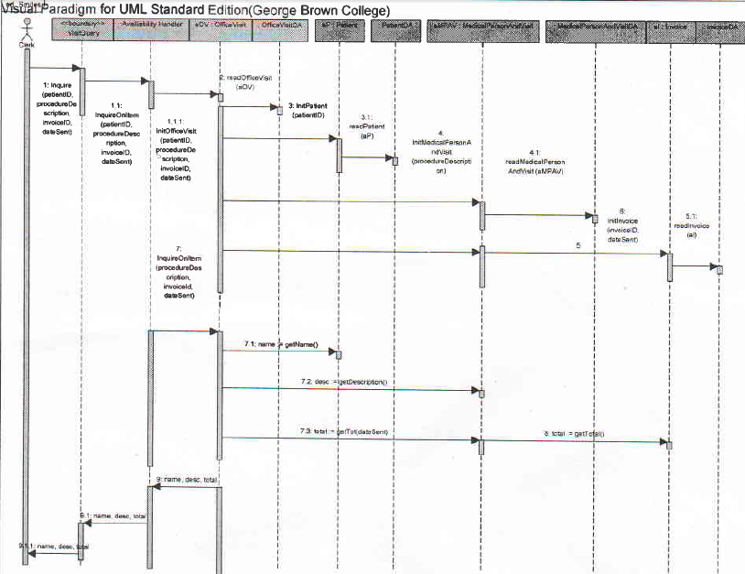

* 1. Design Class Diagram

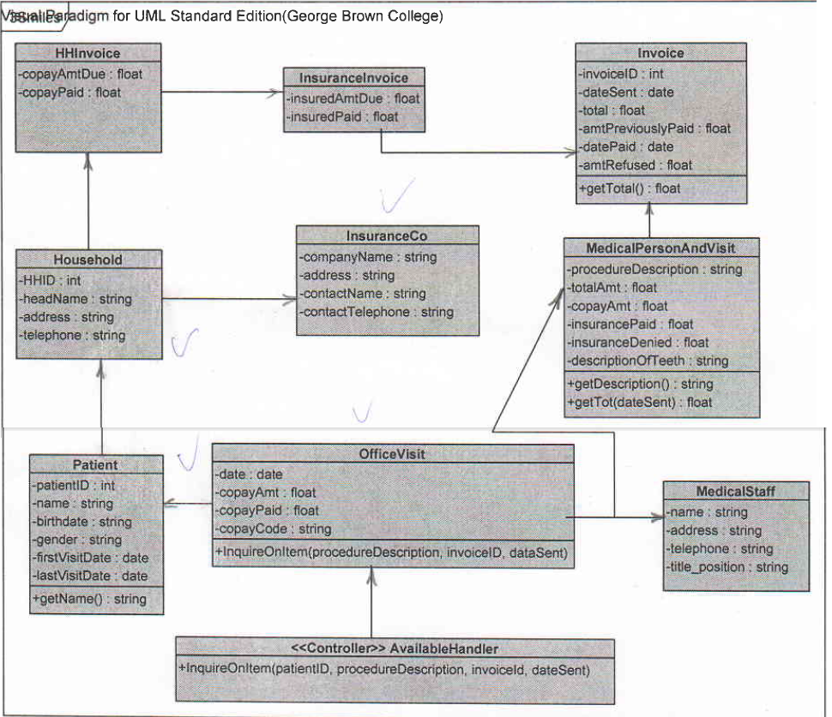

* 1. Package Diagram

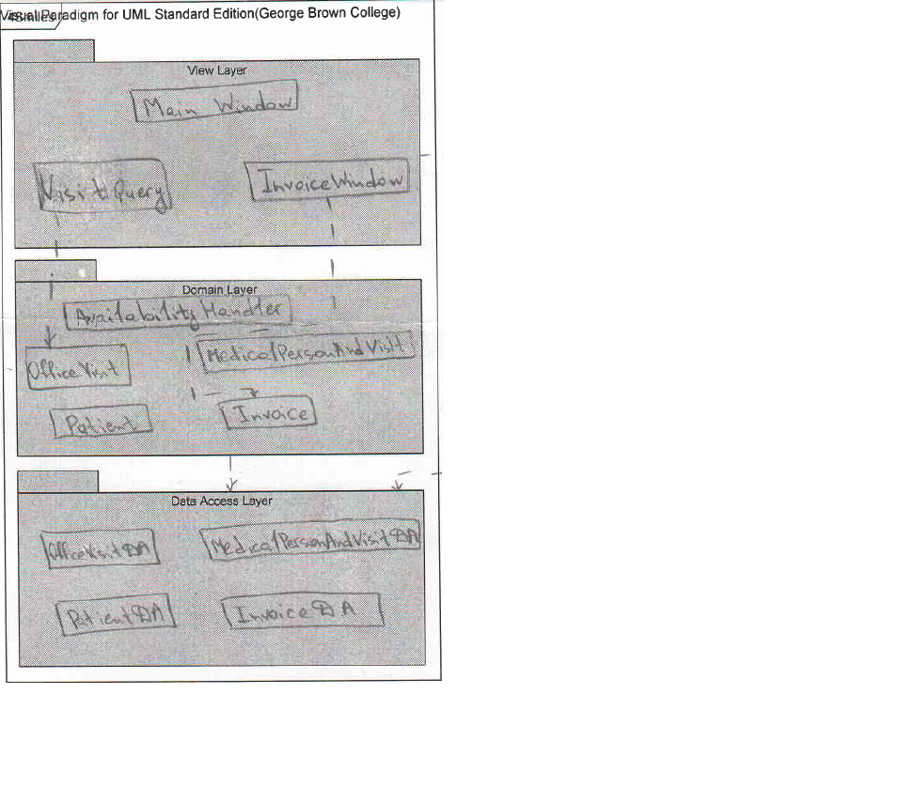

1. Three Layered Use Case Realization through Sequence Diagrams
   1. Class Diagram

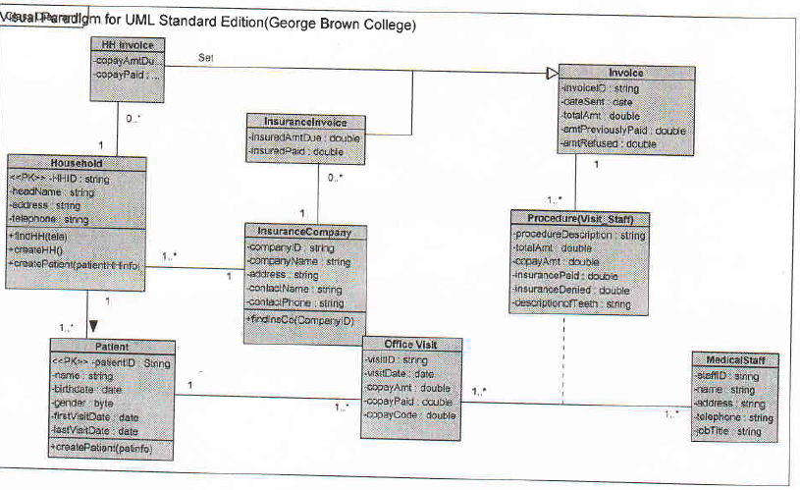

* 1. Three Layered Sequence Diagram

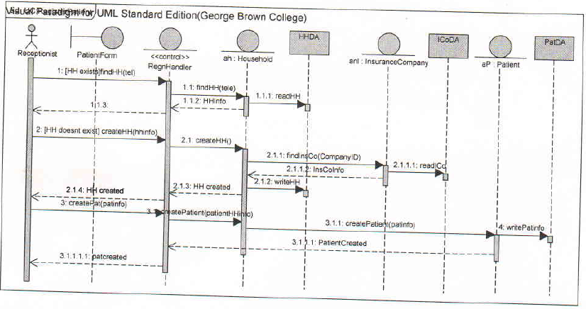

1. Creating an ER Diagram
   1. Fully Normalized ER Diagram

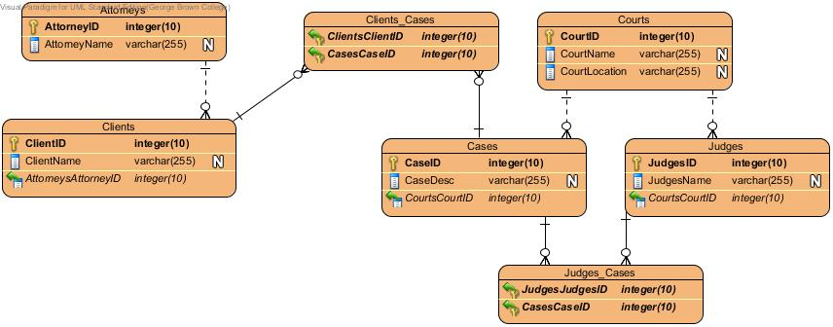

* 1. Generated Class Diagram

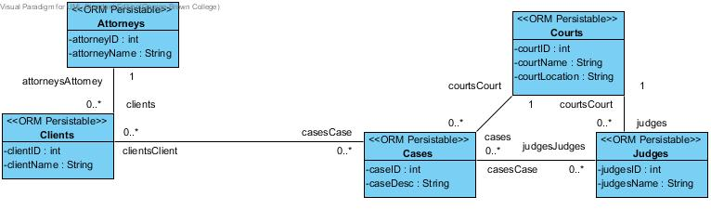

1. USE Scenarios and Windows Navigation Diagram
   1. Use Scenarios

|  |  |
| --- | --- |
| Open new staffing request | Place staff members |
| Use scenario: User is receiving and opening a staffing request | Use scenario: User is checking a staff member information against the database of available professional and scientific staff |
| 1. User enters the contract number into the contract database. | 1. User checks the type of staff member, experience, and qualifications against the database of available professional and scientific staff (qualified individuals). |
| 1. User will likely review the terms and conditions and determine whether the request is valid. | * 1. Found: he or she is marked “reserved” in the staff database. |
| * 1. Valid: if the contract has not expired, the type of professional or scientific employee requested is listed on the original contract, and the requested fee falls within the negotiated fee range. The contract manager enters the staffing request into the staffing request database as an outstanding staffing request. | * 1. Not found or is not available now: user creates a memo that explains the inability to meet the staffing request and attaches it to the staff request. |
| * 1. Not valid: the user sends the staffing request back to the client with a letter staying why the staffing request cannot be filled, and a copy of the letter is filled. | 1. All requests are sent to the arrangements department. |
| 1. User sends the staffing request to the placement department. |  |

* 1. Windows Navigation Diagram

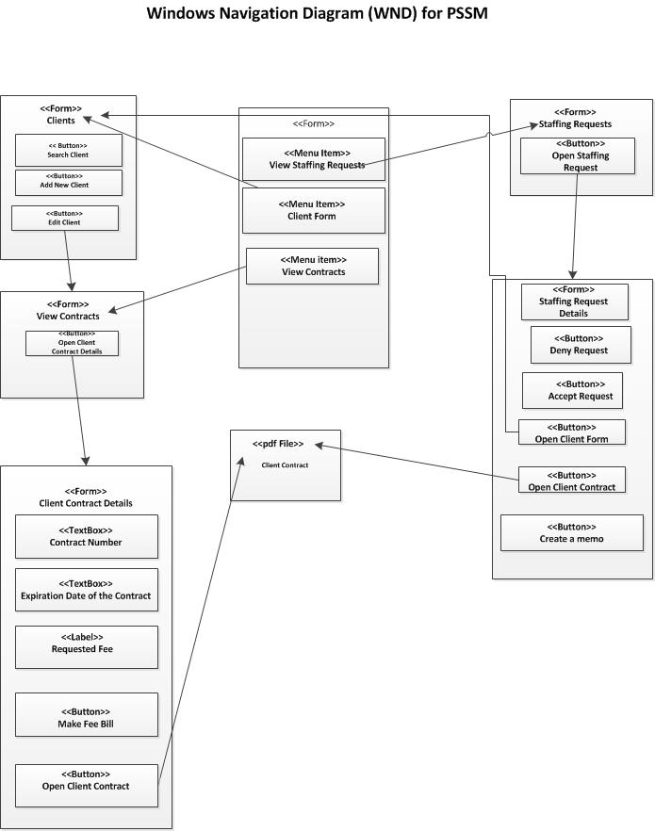

* 1. Language Prototype for HCI

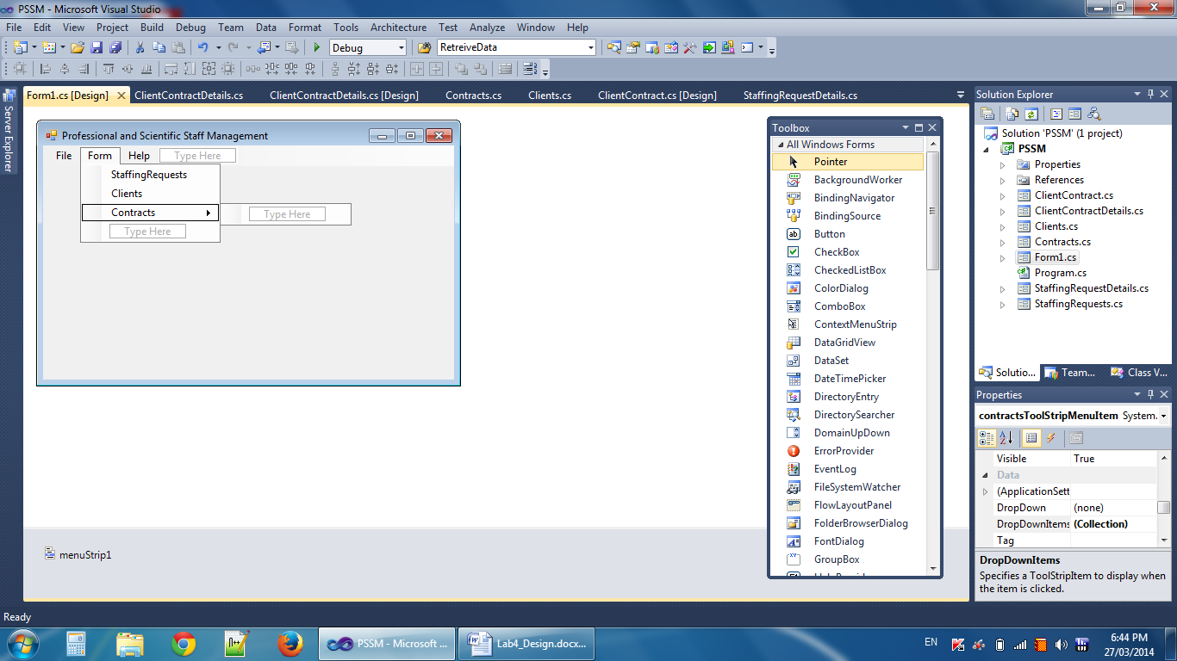

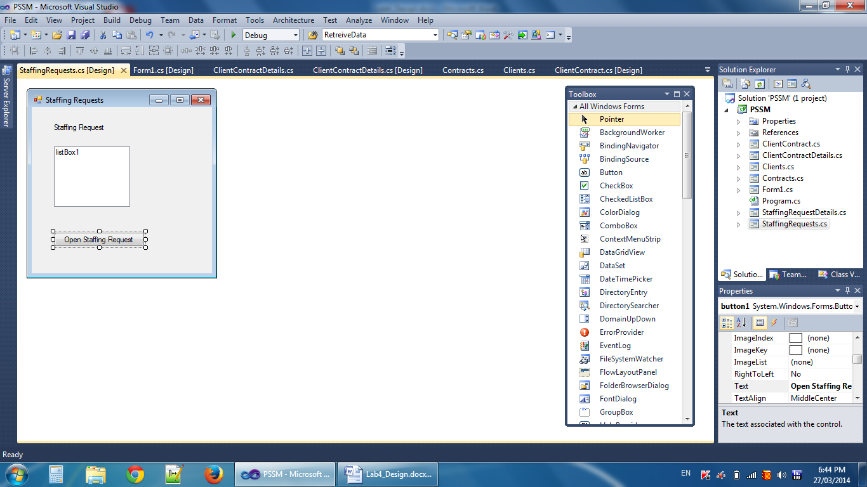

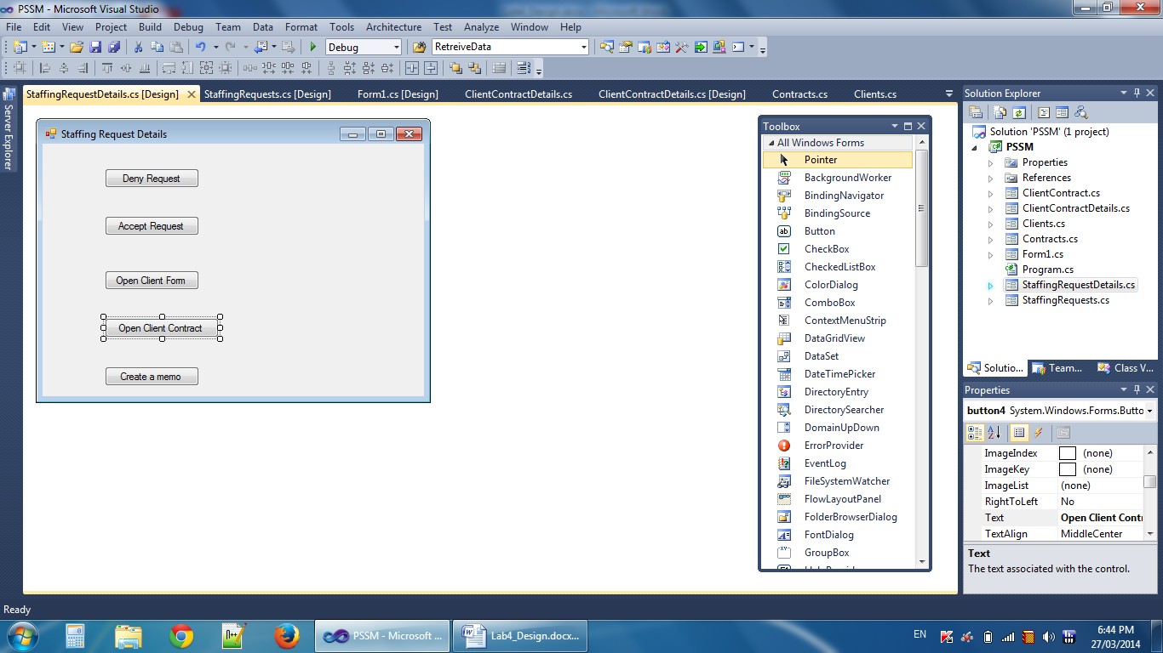

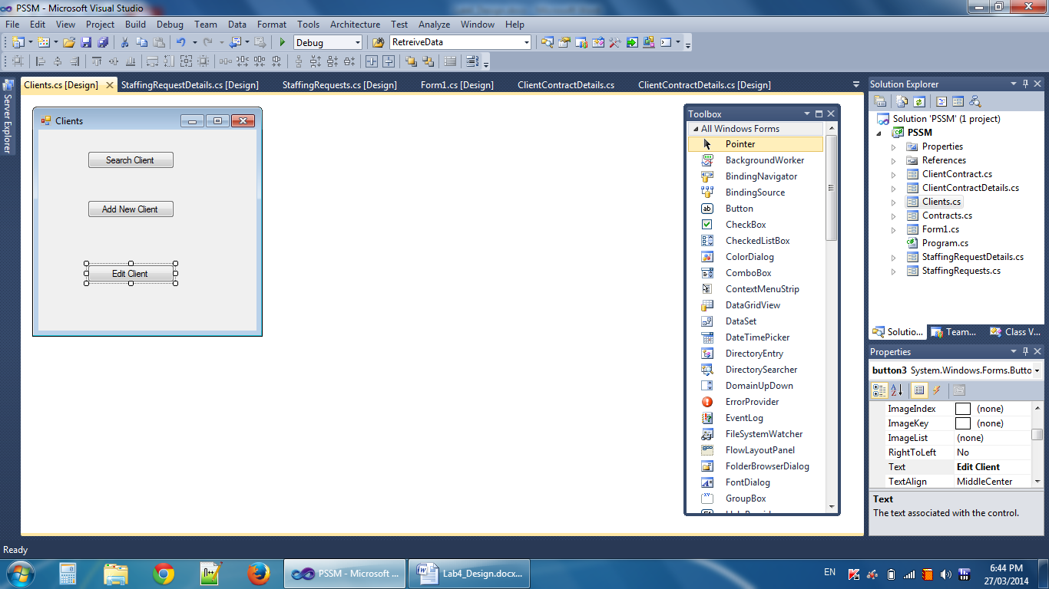

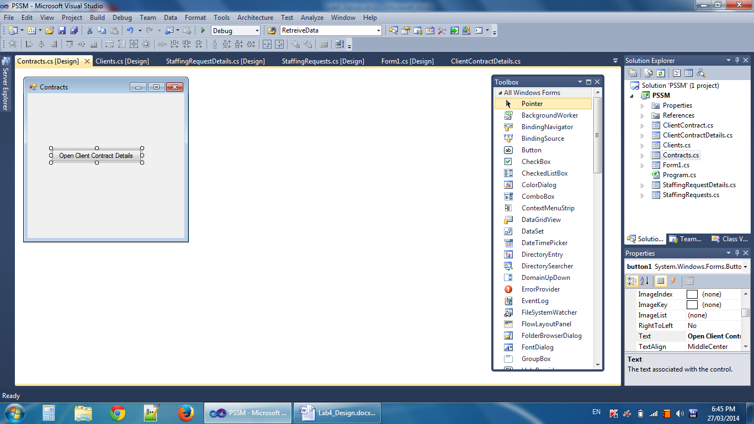

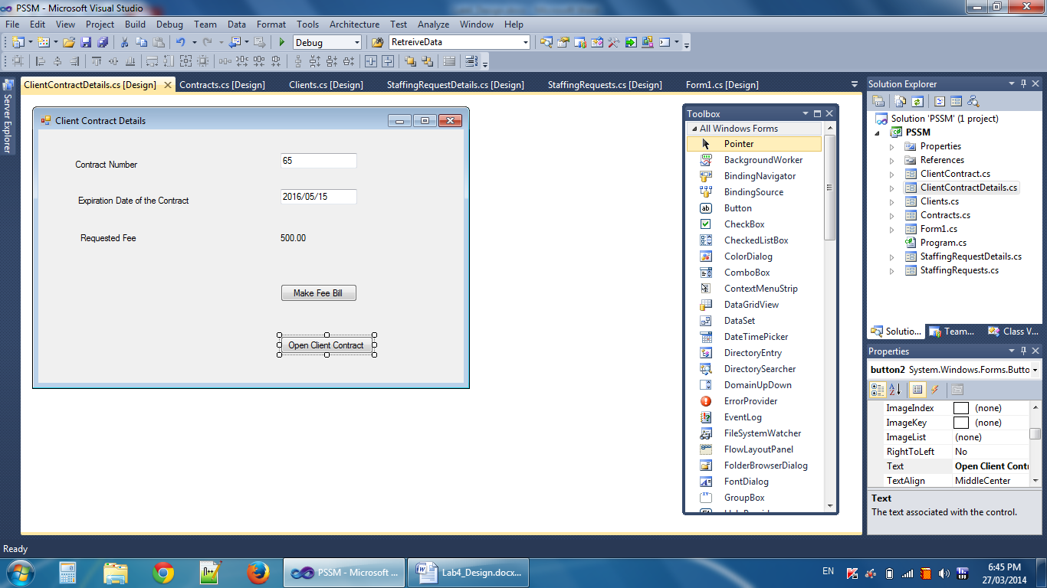

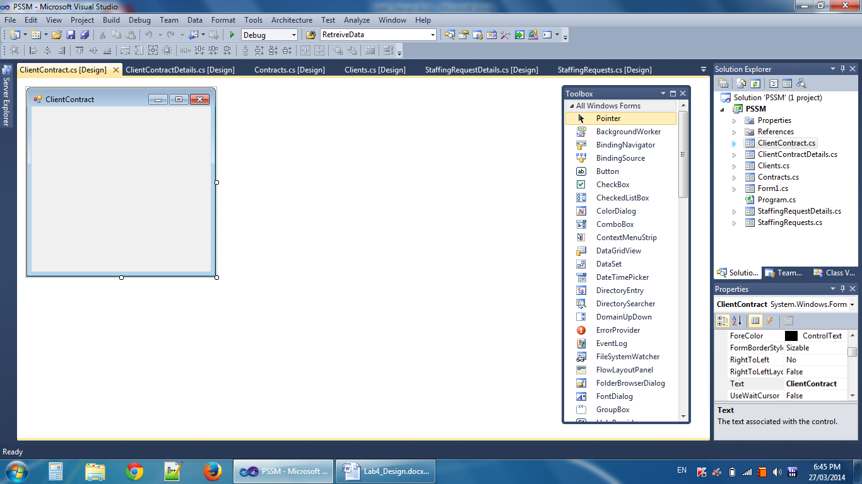

1. Design Statecharts
   1. In- Class Example

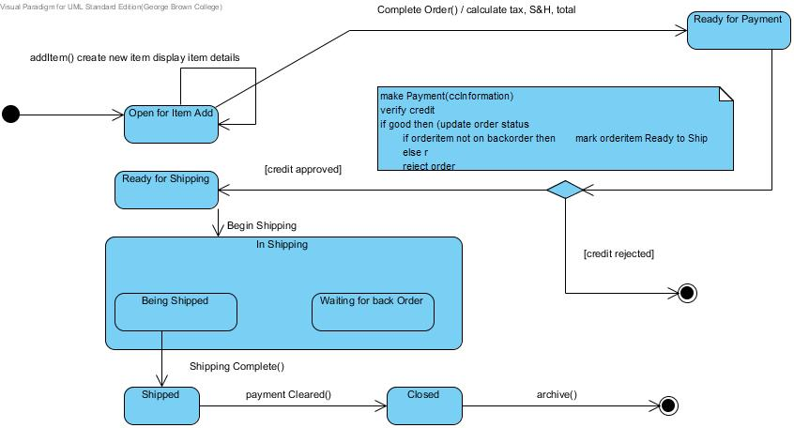

* 1. Real Estate Listing System Example

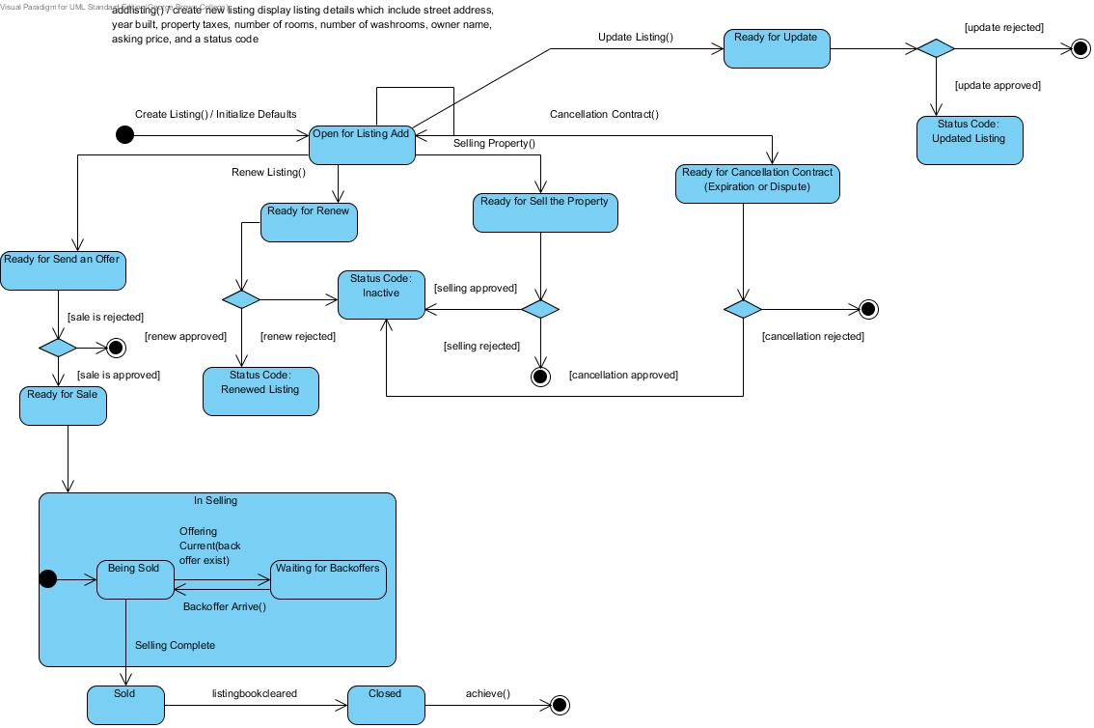

1. Deployment Diagram

